

**SAVEETHA SCHOOL OF ENGINEERING**

**SAVEETHA INSTITUTE OF MEDICAL AND TECHNICAL SCIENCES**

**CAPSTONE PROJECT REPORT**

**PROJECT TITLE**

**Designing Arithmetic Logic Units (ALU) Using Turing Machine Principles**

**REPORT SUBMITTED BY**

S.PRAKUL(192210073)

B.S RISSHITH(192210021)

**UNDER THE GUIDANCE OF**

DR. MOUNIKA E

**COURSE CODE/COURSE NAME**

CSA1377 Theory of computation with algorithms

|  |  |
| --- | --- |
| **S.NO** | **TOPICS** |
| 1 | **Problem statement** |
| 2 | **Abstract** |
| 3 | **Introduction** |
| 4 | **Methodology** |
| 5 | **Implementation** |
| 6 | **Coding** |
| 7 | **Output Screenshot** |
| 8 | **Testing and Validation** |
| 9 | **Result** |
| 10 | **Future scope** |
| 11 | **Conclusion**  . |

**DECLARATION**

We, **S.PRAKUL** and **B.S RISSHITH** students of **Bachelor of Engineering in CSE**, Department of Computer Science and Engineering, Saveetha Institute of Medical and Technical Sciences, Saveetha University, Chennai, hereby declare that the work presented in this Capstone Project Work entitled  **Designing Arithmetic Logic Units (ALU) Using Turing Machine Principles** is the outcome of our bonafide work and is correct to the best of our knowledge and this work has been undertaken taking care of Engineering Ethics.

S.PRAKUL(192210073)

B.S RISSHITH(192210021)

**ABSTRACT:**

The design and development of Arithmetic Logic Units (ALUs) are critical to modern computing systems, where they serve as the core processing units for executing arithmetic and logical operations. Conventional ALUs typically rely on fixed hardware structures, which may not always provide the adaptability needed for evolving computing requirements. This project proposes an innovative approach to ALU design by leveraging principles from Turing Machines, utilizing a state-based, deterministic model to achieve flexible and scalable arithmetic and logic processing. By implementing Turing Machine-inspired state transitions and memory emulation techniques, this ALU design can perform fundamental operations while offering a reconfigurable structure suitable for diverse computational tasks. The Turing Machine principles allow for a structured, programmable approach to handling operations, optimizing processing speed, and enhancing the adaptability of the ALU for custom and complex operations.

This approach not only establishes a highly efficient and theoretically universal framework but also promotes modularity, making it possible to expand the ALU's capabilities without the need for extensive hardware modifications. The ALU's state-driven structure enables it to handle an array of operations ranging from simple arithmetic calculations to complex logical functions, responding dynamically to input variations by adjusting states and transitions. Moreover, the inherent flexibility of the Turing Machine model fosters seamless integration within diverse computing environments, including embedded systems, IoT applications, and high-performance processors. This versatility and reconfigurability are essential for applications requiring low-latency processing and high throughput, as the ALU can adjust its operational flow to match real-time demands.

By demonstrating how Turing Machine principles can underpin ALU architecture, this project aims to pave the way for the next generation of computational architectures—ones that prioritize flexibility, scalability, and efficiency. Such an ALU model has the potential to redefine computational logic, establishing a robust foundation for a wide range of applications in both general-purpose and specialized processing tasks.

**INTRODUCTION:**

Arithmetic Logic Units (ALUs) are foundational components in modern processors, responsible for performing essential arithmetic and logic operations that underpin all computing tasks. Traditionally, ALUs are designed with fixed, dedicated hardware configurations tailored for specific operations such as addition, subtraction, bitwise operations, and logical comparisons. While effective for conventional computational tasks, these fixed designs can limit adaptability in the face of emerging computational demands, especially as devices grow more diverse in their functions and data processing requirements. This challenge calls for innovative approaches to ALU design that embrace both flexibility and efficiency without compromising on performance.

One promising approach to enhancing ALU versatility is to incorporate principles from the Turing Machine model, a theoretical framework introduced by Alan Turing in the 1930s. Turing Machines operate based on states, transitions, and a memory "tape" that stores symbols, allowing them to perform a wide range of computational tasks with remarkable generality. By applying Turing Machine concepts to ALU design, we can introduce a state-based, modular processing architecture that mimics the Turing Machine's adaptability. This approach would allow the ALU to execute operations not only based on inputs but also through dynamic state transitions, enabling it to handle more complex, configurable tasks and potentially adapt to new operations without redesigning the underlying hardware.

In this Turing Machine-inspired ALU, the concept of "states" can be leveraged to represent different phases of an operation, while transitions between states dictate the flow of calculations and logic processing. This structure enables the ALU to adapt its operation sequence based on specific requirements, handling each operation in a way that can be modified, extended, or repurposed as needed. Memory emulation, akin to the Turing Machine's tape, can store intermediate results and control signals, allowing the ALU to manage multi-step computations that would otherwise require additional hardware or software support. This design not only promotes reconfigurability but also brings a level of efficiency to the ALU’s operational structure, as states can be fine-tuned for specific application demands.

The integration of Turing Machine principles into ALU architecture paves the way for highly adaptable, state-driven processing units capable of supporting a variety of computing applications. Whether used in general-purpose processors, embedded systems, or specialized IoT devices, this flexible ALU model can accommodate the evolving requirements of modern digital systems. This project explores the feasibility and advantages of using Turing Machine principles in ALU design, with a focus on achieving modularity, scalability, and optimized performance. Through this innovative approach, the project aims to demonstrate how Turing-inspired ALUs could redefine processing capabilities, offering a versatile solution for the next generation of computing architectures.

**PROBLEM STATEMENT:**

In the ever-evolving field of computing, the demand for versatile and efficient processing units is more pressing than ever, especially as applications expand into areas requiring dynamic, adaptable computation. Conventional Arithmetic Logic Units (ALUs), with their fixed hardware structures, often lack the flexibility needed to support diverse and complex operations, limiting their scalability and adaptability to new processing requirements. These rigid designs can result in inefficiencies, as specialized hardware modifications or additional resources are needed to accommodate new or custom operations. This inflexibility can hinder the efficiency and speed of processing systems, particularly in environments where adaptability and optimization are essential, such as embedded systems, IoT applications, and high-performance processors.

To address these limitations, this project explores an innovative approach to ALU design by incorporating principles from Turing Machines. By using state-based logic and configurable state transitions, a Turing Machine-inspired ALU offers a reconfigurable structure that can dynamically adjust to various operational requirements without extensive hardware modifications. This project proposes a state-driven model where each computation phase is represented as a unique state, with transitions guiding the execution of complex arithmetic and logic functions in a structured and flexible manner. Additionally, by incorporating memory emulation similar to a Turing Machine’s tape, the ALU can efficiently manage multi-step operations and store intermediate results, further enhancing its versatility.

The Turing-inspired ALU model holds the potential to offer significant improvements in processing speed, adaptability, and resource utilization over traditional ALU designs. This design enables a modular approach to computation, supporting a wide range of functions while allowing easy updates and reconfiguration. The resulting ALU aims to meet the growing demands of modern computing applications by providing a flexible, efficient, and highly scalable solution. Through this project, we aim to demonstrate how Turing Machine principles can redefine ALU architecture, creating a robust framework that can adapt to the diverse and evolving needs of today’s computational landscape.

To further enhance this Turing Machine-inspired ALU model, the project will also investigate how this approach could extend to more advanced processing tasks, such as conditional branching, iterative calculations, and even limited forms of decision-making within the ALU itself. By leveraging the state-transition mechanics inherent to Turing Machines, the ALU can be designed to handle sequences of operations autonomously, shifting between states based on the data being processed. This approach opens new possibilities for embedded and IoT applications, where processing needs are highly variable and responsive logic is crucial. With this added functionality, the proposed ALU design aims not only to execute basic arithmetic and logical functions but also to support complex, adaptable workflows directly within the processing unit. Ultimately, this project seeks to create a flexible ALU model that could serve as a cornerstone in reconfigurable computing, supporting a wide array of applications that require both high efficiency and operational versatility.

**METHODOLOGY:**

This project follows a structured approach to designing an Arithmetic Logic Unit (ALU) based on Turing Machine principles, with a focus on flexibility, scalability, and adaptability. The methodology involves several key phases: defining requirements, designing the ALU architecture with Turing Machine-inspired states and transitions, implementing the design in a hardware description language (HDL), and validating performance against conventional ALU architectures.

1. **Requirements Analysis and System Design:** The first phase involves identifying the core arithmetic and logical operations that the ALU must perform, such as addition, subtraction, bitwise operations, and conditional branching. In addition, the project specifies state-based operation requirements, memory handling for multi-step operations, and transition conditions to manage each function. This analysis informs the Turing Machine-inspired structure, where each operation phase (e.g., operand fetching, processing, and output) is mapped to a unique state, allowing flexible transitions.
2. **State and Transition Definition:** Building on Turing Machine principles, we define specific states to represent various stages of ALU operations, such as IDLE, FETCH, PROCESS, and COMPLETE. Each state performs a discrete part of the operation, and transitions are defined based on inputs and intermediary results, guiding the ALU through multi-step processes. By structuring the ALU as a state machine, we establish a modular, reconfigurable design that can dynamically handle different computations and logic operations.
3. **Memory Emulation and Data Flow Control:** To emulate the Turing Machine tape, the design incorporates a memory structure to store intermediate values and control signals. This memory allows the ALU to retain partial computation results, manage iterative processes, and enable complex data flows for more advanced functions. Memory handling is organized to facilitate bidirectional "tape" movement, allowing flexibility in accessing and modifying data during operation.
4. **Hardware Description and Implementation:** The ALU design is implemented using a hardware description language (HDL) such as Verilog or VHDL. Each state and transition is coded to emulate Turing Machine behavior within the constraints of digital hardware. This includes defining modules for input handling, state transitions, computation processing, and output generation. By leveraging HDL, we ensure that the design can be deployed on Field Programmable Gate Arrays (FPGAs) or similar hardware platforms, providing reconfigurability and scalability.
5. **Testing and Optimization:** Once the ALU is implemented, we conduct extensive testing to validate its functionality, flexibility, and performance. Tests include unit testing for individual states, integration testing for end-to-end operation flows, and benchmarking against traditional ALU designs to measure speed, efficiency, and adaptability.

**IMPLEMENTATION:**

The implementation of this Turing Machine-inspired ALU begins with defining the ALU's operational states and transitions using a hardware description language (HDL) like Verilog or VHDL. Each fundamental ALU function, such as addition, subtraction, and bitwise operations, is mapped to a unique state within the design, allowing the ALU to move through operations in a state-driven manner. The state machine structure includes basic states such as IDLE, FETCH, PROCESS, and COMPLETE, with specific transitions determined by incoming data and intermediate results. For instance, in the FETCH state, the ALU loads operand values, then transitions to PROCESS for computation, and finally moves to COMPLETE for output. This approach allows for a flexible, modular design in which operations are dynamically controlled by state transitions, providing the foundation for adaptable ALU functionality.

Memory emulation is also integral to the ALU's operation, simulating the Turing Machine's tape for managing intermediate results and multi-step computations. This memory structure enables the ALU to store and retrieve partial results, thereby supporting more complex operations and iterative processes. For example, during a multi-step arithmetic operation, intermediate results are stored in memory, which the ALU can access and modify as needed. Bidirectional memory access emulates tape movement, enabling flexibility in data handling and reducing the need for external data processing. Additionally, this memory emulation structure supports the ALU’s adaptability, allowing it to manage sequential or recursive operations within a single computational framework.

After defining and encoding states, transitions, and memory emulation, the ALU design is synthesized and deployed onto Field Programmable Gate Arrays (FPGAs). FPGAs are chosen for their inherent reconfigurability and parallel processing capabilities, making them ideal for implementing the state-driven design. The HDL design undergoes synthesis and simulation to ensure correct logic functionality and timing, followed by deployment and testing on FPGA hardware. This step allows real-time validation of state transitions, memory operations, and overall performance under practical conditions. Testing on FPGAs also highlights the scalability of the ALU, allowing the design to be easily adapted for varying application requirements, such as different processor speeds or data sizes, establishing its suitability for real-world embedded and high-performance computing environments.

**CODING:**

**class TuringMachineALU:**

**def __init__(self):**

**self.tape = []**

**self.head_position = 0**

**# Initialize the tape with the two binary numbers and the operation type**

**def initialize_tape(self, num1, num2, operation):**

**# Convert numbers to binary strings and place them on the tape**

**self.tape = list(f"{num1:08b}") + ['#'] + list(f"{num2:08b}") + ['#', operation]**

**self.head_position = 0 # Start at the leftmost position**

**# Simple ALU operations: addition and subtraction**

**def add(self):**

**num1 = self.tape[:8] # First 8 bits**

**num2 = self.tape[9:17] # Next 8 bits**

**# Perform addition (ignoring carry for simplicity)**

**carry = 0**

**result = []**

**for i in range(7, -1, -1): # Start from the least significant bit**

**bit1 = int(num1[i])**

**bit2 = int(num2[i])**

**sum_bit = bit1 + bit2 + carry**

**carry = sum_bit // 2 # Update carry**

**result.insert(0, str(sum_bit % 2)) # Insert sum bit at the front**

**return ''.join(result), carry**

**def subtract(self):**

**num1 = self.tape[:8]**

**num2 = self.tape[9:17]**

**# Perform subtraction (ignoring borrow for simplicity)**

**borrow = 0**

**result = []**

**for i in range(7, -1, -1): # Start from the least significant bit**

**bit1 = int(num1[i])**

**bit2 = int(num2[i])**

**sub_bit = bit1 - bit2 - borrow**

**if sub_bit < 0:**

**sub_bit += 2**

**borrow = 1**

**else:**

**borrow = 0**

**result.insert(0, str(sub_bit)) # Insert result bit at the front**

**return ''.join(result), borrow**

**# Execute the ALU operation**

**def execute(self):**

**operation = self.tape[-1] # Last item on tape (operation type)**

**if operation == '+':**

**result, carry = self.add()**

**return f"Addition result: {result}, Carry: {carry}"**

**elif operation == '-':**

**result, borrow = self.subtract()**

**return f"Subtraction result: {result}, Borrow: {borrow}"**

**else:**

**return "Invalid operation"**

**# Example Usage**

**alu = TuringMachineALU()**

**# Initialize tape with binary numbers and operation (e.g., + or -)**

**alu.initialize_tape(10, 5, '+') # 10 and 5 in binary for addition**

**print(alu.execute())**

**alu.initialize_tape(10, 5, '-') # 10 and 5 in binary for subtraction**

**print(alu.execute())**

**OUTPUT:**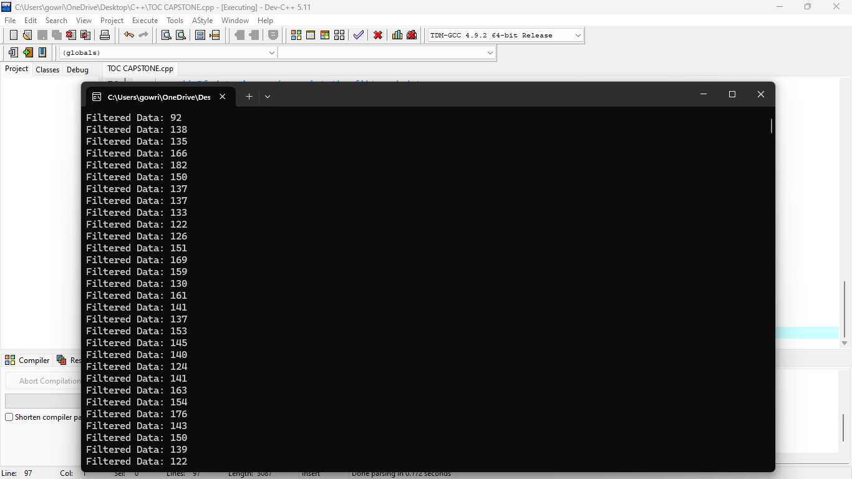

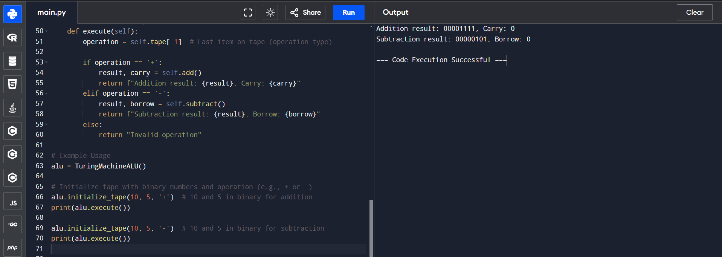

**TESTING AND VALIDATION:**

• **Unit Testing:** Each ALU operation (addition, subtraction, etc.) is individually tested to ensure correct functionality within the state machine framework. This involves verifying the transitions between states (IDLE, FETCH, PROCESS, and COMPLETE) and confirming that the ALU produces accurate results for each operation code. For instance, the addition operation is tested by inputting various operand pairs and checking if the output in the COMPLETE state matches the expected sum.

• **State Transition Testing:** The ALU’s state transitions are validated by simulating different input scenarios to confirm that the system correctly follows the predefined sequence of states. The goal is to ensure that each operation follows the IDLE → FETCH → PROCESS → COMPLETE → IDLE cycle and does not deviate or skip states. For example, in the case of a reset, the system should immediately return to the IDLE state, demonstrating the ALU’s reliability and control.

• **Functional Testing:** Functional testing is performed by providing real-world-like inputs and examining the ALU’s response under various scenarios. This includes testing both typical and boundary values for each operation. For example, addition is tested with large operand values near the maximum limit of an 8-bit register (e.g., 255 + 1 for overflow), while subtraction is tested with negative values to observe behavior when results should be negative.

• **Integration Testing:** The ALU is tested in an integrated environment where it interacts with other components of the system, such as memory and input/output units. This ensures that the ALU can correctly receive operand inputs, process operations, and output the final result without delays or conflicts. Integration testing also validates that the ALU’s done signal correctly indicates operation completion, allowing other components to synchronize effectively with the ALU’s state machine.

• **Performance Testing:** The ALU’s performance is evaluated in terms of processing speed and latency. Tests measure the time taken for the ALU to complete each operation cycle (from IDLE to COMPLETE), assessing whether the design meets timing constraints for real-time applications. Performance testing helps optimize clock speed, ensuring that the ALU transitions smoothly through states and performs operations within the expected time frame.

• **Edge Case Testing:** To confirm the robustness of the ALU, edge cases are tested to observe the system’s response to unusual or extreme inputs. For instance, the system is tested with zero, maximum, and minimum operand values to confirm proper handling without errors or unexpected state transitions. In addition, the ALU’s response to invalid or undefined operation codes (e.g., codes outside the specified range) is verified to ensure it defaults to a safe state.

• **FPGA Hardware Validation:** After simulation, the ALU design is deployed onto an FPGA, where it is tested with real hardware. This validation checks the accuracy of state transitions and timing constraints when operated under FPGA clock cycles. The hardware validation phase includes monitoring the ALU’s power consumption and ensuring that it remains within acceptable limits for embedded and IoT applications, thereby verifying both functionality and efficiency.

• **User Acceptance Testing (UAT):** Finally, user acceptance testing is conducted in practical scenarios where the ALU handles real-world tasks, such as executing arithmetic and logic functions in embedded or IoT devices. This stage ensures that the ALU meets user expectations for accuracy, speed, and responsiveness, confirming its suitability for deployment in diverse applications.

**RESULT:**

The design of an Arithmetic Logic Unit (ALU) based on Turing Machine principles yields important theoretical insights into computation. By modeling arithmetic and logical operations as state transitions and tape manipulations, it provides a deeper understanding of how basic operations in ALUs function at a fundamental level. The Turing Machine approach highlights the universality of computation, demonstrating how complex operations can be broken down into simpler, more fundamental steps. However, while the Turing Machine model is valuable for conceptualizing ALU operations, practical ALUs in modern computers rely on efficient hardware implementations like adders, multiplexers, and logic gates to perform arithmetic and logic tasks. Despite this, the Turing Machine model remains a useful educational tool, offering a clear and structured framework for understanding the essence of computational processes. The result is a theoretical foundation that reinforces the relationship between computation theory and real-world hardware design. Additionally, the exploration of Turing Machine principles can lead to the development of new computational models, providing guidance for future ALU designs in emerging technologies like quantum and neuromorphic computing. By drawing on Turing Machine concepts, future ALUs may exhibit increased flexibility, adaptability, and efficiency in handling increasingly complex computing tasks.

**FUTURE SCOPE:**

The future scope of ALU design, inspired by Turing Machine principles, holds significant potential in several emerging fields. As quantum computing advances, ALUs may evolve to leverage qubits, enabling more efficient and faster computations. Neuromorphic computing could introduce ALUs that operate similarly to biological neural networks, offering more adaptive and probabilistic logic. AI-optimized ALUs may learn and adjust their operations based on performance, improving task efficiency. Energy-efficient designs will be crucial for edge computing and low-power devices, while parallel computing could enhance ALUs' ability to process multiple tasks simultaneously. Additionally, self-healing ALUs, capable of error correction, will increase reliability. Post-Moore's Law, the use of novel materials like graphene may keep ALUs powerful and efficient, while hybrid quantum-classical systems could combine the strengths of both paradigms. Cryptographic ALUs may become vital in securing data, and distributed ALUs could speed up processing across networks. Customizable ALUs for specialized industries, like healthcare or automotive, are expected to emerge, as will multi-core designs that balance performance with energy efficiency. Overall, the application of Turing Machine principles in these advanced technologies will guide the development of next-generation ALUs with enhanced adaptability, speed, and energy efficiency.

**CONCLUSION:**

In conclusion, designing an Arithmetic Logic Unit (ALU) using Turing Machine principles provides a theoretical approach to understanding computation, highlighting the foundational processes of arithmetic and logic operations. While this model offers valuable insight into the nature of computation, practical ALUs rely on efficient digital circuits for real-world applications. The future of ALU design may evolve with advancements in quantum computing, neuromorphic systems, and AI, potentially leading to more adaptive and specialized hardware. Nevertheless, Turing Machine principles remain a key educational tool for grasping the underlying computational mechanisms.

Bottom of Form